Exploring the link between Cost Centres and Ledger Codes on your finance system in relation to the Consistent Financial Return (CFR).

The CFR Report:
As a maintained school or pupil referral unit it is a requirement from the DfE that you should submit a Consistent Financial Report following the end of a financial year and upload it to the ‘COLLECT’ area from your DfE login.
The report records the funding and income you have received during the financial year and how you have spent it. A standard template is used for all schools. Once it has been uploaded to COLLECT and ratified by your Local Authority, it is then uploaded the DfE benchmarking website whereby schools can produce comparative reports for discussion with governors.
It is usual that most maintained schools will procure outside financial support to help produce the final report before submission. The CFR report is based on income and expenditure that you have coded to a ledger code, not the cost centre code. Coding accurately is the key to ensuring your CFR report is correct. It can take up to 3 hours to check everything for the year has been coded to the correct place and to produce an accurate report. You can help by ensuring income and expenditure not only has been coded to the correct cost centre, but that the ledger code used is relevant for the transaction you are processing.
Below is an extract of some of the income and expenditure CFR codes used for revenue transactions.
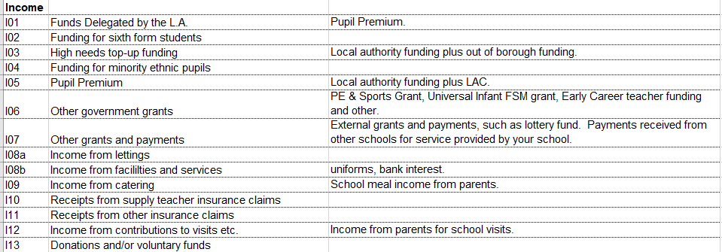

Expenditure
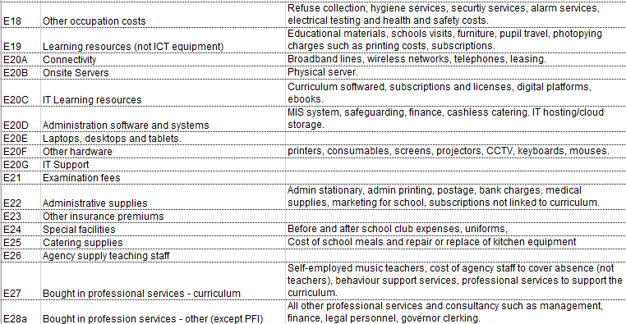

Each CFR code has clear criteria of the income and expenditure can be linked to it. The above descriptions are just a brief overview. Full details and a comprehensive guide is available on the DFE website; https://www.gov.uk/guidance/consistent-financial-reporting-framework-2025-to-2026

How does your finance system link to the CFR report coding?
Each ledger code within your finance system has a CFR code attached to it and this is where the CFR report is generated from. For example, if you have a ledger code for educational materials where you code items such as books, educational resources etc, this should be linked to CFR code E19 Learning Resources.

Why does it take so long to check the CFR report before submission?
As part of your finance SLA your Support Consultant will check that the ledger codes mapped to the CFR codes are correct and will investigate any anomalies and may have to complete journals to ensure that the income and expenditure has been coded correctly.
One of the common mistakes found is when a ledger code has been used for a number of transactions that do not relate to that particular code and therefore will not be separated out correctly on CFR.
Referring back to the ‘educational materials’ ledger code, it should be used for books and educational resources such as exercise books, art supplies, stationery for the classroom etc. In some cases, it may have been used to code IT subscriptions and licenses, printer consumables, outside agency support for sports activities. For CFR these costs should be shown in E20C for IT Subscriptions and licenses, E20F for printer consumables and E27 for agency support for sports. If these expenditure items were not moved to the correct CFR code, your benchmarking report would be incorrect.
The key to ensuring the right income and expenditure is coded to the right CFR code is to use relevant ledger codes for those transactions and ensure they are linked to the cost centre you want to use.
Top tip. Never use a code title ‘miscellaneous expenses’ or ‘supplies and services’! There is not such thing as a random expense and usually we find all and sundry coded to these ledger codes. We would wish these codes be removed from your finance system forever!

Know your finance system and chart of accounts.
Cost centres and ledger codes are the core accounting tools used to categorise, track and report on key financial activity for your school.
Cost centres identify the main budget and ledger codes are used to break down financial activity further. Some cost centres will have just one ledger code attached to them such as Electricity, Gas, Water, rates. Whilst other cost centres will have numerous ledger codes attached.
It is essential when entering purchase orders, invoices, journals on your finance system that you code the item to the correct cost centre first, then the correct ledger code. If you are not sure where to code an item to, check your chart of accounts. Have a look at which ledger codes are mapped to the cost centre you want to use and make sure the correct ledger code has been linked. If it hasn’t, link the correct ledger code before inputting the transaction.
It is a common mistake to use any available ledger code in the cost centre and then think to move it later, or to get your support consultant to move it. This is an inefficient use of time when it is an easy fix in the first instance.
For example; you may have a separate cost centre for the PE Grant expenditure, transactions in this cost centre could include sports equipment, instructor fees for lunchtime sessions, CPD sessions for staff, costs associated with local school sports competitions. It is advisable that different ledger codes are used for each type of expenditure, for CFR purposes the expenditure will be split into the following categories:

Sports equipment – E19 Learning resources (includes non-ICT learning equipment).
Instructor fees – E27 Bought-in professional services – curriculum (includes the cost of self-employed agency provision).
CPD Sessions – E09 Staff development and training – self-explanatory.
Cost associated with local school sports competitions – E19 Learning resources (includes school trips and educational visits and cost of transport).

Regular monthly checks.
As part of your role as Business Manager you should be reviewing income and expenditure monthly by reviewing your budget monitoring report. It would be prudent for you to cast your eye over a more detailed report of your cost centres and ensure transactions have also been coded to the correct ledger code. Therefore, corrections can be completed monthly instead of taking up valuable visit time when your CFR report is due.

