Planning for Change
  - An Assess, Plan, Do, Review (APDR) Toolkit for Emotional Barriers to School Attendance (EBSA)




Assess (Information Gathering) 3
Section 1: Understanding the child 4
B. Laddering Exercise 6
C. Questionnaire (young person version) 9
D. Card sort – What helps? 12
E. Questionnaire for children making a fresh start 20
Section 2: Working with parents/Carers 24
Questionnaire (parent version) 25
Section 3: Information gathering from staff 29
Plan 30
Suggested reasonable adjustments 32
Example of a support plan 344
Do 356
Review – Support Plan Review 357

Assess (Information Gathering)

Possible indicators of EBSA include:
- Child/young person reluctant to leave home and stays away from school.
- Reluctance to leave parents, get out of the car or a high level of worry about what is happening at home: consider safeguarding concerns if child is worrying about home, this may not be attachment.
- Regular absences, including for ‘minor’ illnesses.
- Patterns in absences, for example, particular days and/or subjects, after weekends/holidays etc.
- The child or young person feels unable to attend a class or school.
- Evidence of under-achievement compared to their learning potential which could be caused by heightened emotions, difficulty in concentration, masking their needs to appear to be coping or similar.
- Social isolation, bullying, ongoing friendship difficulties leading to avoidance of peers and low mood/depression as well as low self-esteem and confidence.
- Behaviours that challenge, which could look like significant emotional upset, particularly in relation to specific situations at school or demands (e.g., meltdowns, refusal, threats, insults, aggression).
- Physical changes or symptoms (stomach aches, extreme tiredness/difficulty sleeping, feeling sick, headaches, panic attacks, aching, unexplained pains, sudden weight gain or weight loss etc.).

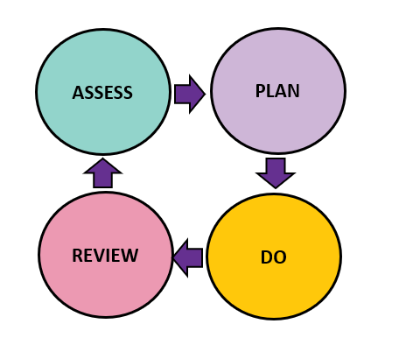

Section 1: Understanding the child



The following pages provide different resources to gather the child’s voice. Select the ones you feel appropriate depending on the age and individual circumstances of the child.
- Start with an informal discussion with the child about how school is going. After this, you may feel in a position to make positive changes. You may then select from the following:
  - An About Me profile may further your understanding of the young person’s needs and challenges. https://www.manchesterlco.org/about-me-templates/
  - Laddering exercise
  - Questionnaire
  - What helps? Card sort
  - Questionnaire for children making a fresh start

Other
How I Communicate
Everyday information
How to Support Me
Keeping me safe and well
My Strengths
Things I need help with
Add picture here
Name:
My Likes
ME
ABOUT
Date written:______________

Updated by: ______________

B. Laddering Exercise

A laddering exercise can be used to rank a range of anxiety-provoking situations.
Follow-up questions might be useful to further explore.

An example laddering exercise is below. Cut out each of the statements, and rank
them from most difficult to easiest. Blank ones have been included for you or the
child/young person to add your own.

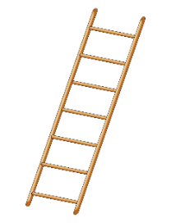

Table 1: Ladder exercise sheet
Going into a busy dining hall.    This Photo by Unknown Author is licensed under CC BY-SA | Going into school with everyone else. | Wearing my school uniform.    This Photo by Unknown Author is licensed under CC BY-SA
  Asking for help. | Talking with friends at break time.   | Playing a game supervised by an adult (e.g., football).  
English lessons.   | Language lessons (e.g., French or Spanish).   | Maths lessons.    This Photo by Unknown Author is licensed under CC BY-NC
Getting changed for PE.   | PE lessons.   | Going to the toilet when it is busy.  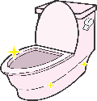  This Photo by Unknown Author is licensed under CC BY-NC
  Being asked a question in class.  This Photo by Unknown Author is licensed under CC BY-SA |   Travelling to school. |   Leaving the house.
  Saying goodbye to my parent(s).  This Photo by Unknown Author is licensed under CC BY-SA | Packing my bag.   | The corridors between  lessons.  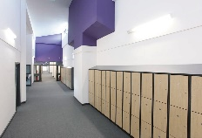
Getting something wrong in lesson.   | Reading out loud  in a lesson.   | Assembly.    This Photo by Unknown Author is licensed under CC BY-NC-ND
Following school  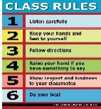  rules.  This Photo by Unknown Author is licensed under CC BY-SA-NC |   Homework.  This Photo by Unknown Author is licensed under CC BY-NC-ND | Doing exams or  tests  

Walking into school via the office.
This Photo by Unknown Author is licensed under CC BY-NC

C. Questionnaire (young person version)

Your strengths

What are you good at? What do you enjoy? What do you like learning about?

When did you start finding school difficult?

What helps you? What do you think might help?

Which adults help you in school?

How’s it going with your friends?
Table 2: Questionnaire on areas found in a school setting
Area | Contributing Factors | Comments (e.g., yes this is an issue or not an issue)
Peer relationships   | - Do you have any close friends? Do you have a friendship group?  - Any fall outs?  - Problems with social media and/or cyberbullying?  - What do you do at breaks and lunchtimes?  - Do you feel lonely?  - Have you been bullied?  - Do you feel different to your friends?
Staff relationships and staff approaches    This Photo by Unknown Author is licensed under CC BY-NC | - Do you feel certain teachers are too strict or not strict enough?  - Are you upset by shouting or raised voices?  - Are you worried about teachers being angry with you?  - Can you ask adults for help?  - Is there anything else you would like to say about adults in your school?
School environment   | Are you overwhelmed or upset by:  - Busy, noisy corridors  - Moving rooms for different lessons  - The dining hall  - Aspects of the school uniform  - Background noise  - Bright lights  - Anything else in the school environment?
Learning/ curriculum   | - Do you worry about getting things wrong or getting into trouble?  - How is your reading?  - Is writing uncomfortable or difficult?  - How is your maths?  - Do you understand the teaching?  - Do you find it difficult to concentrate?  - Do you manage to keep up in lessons?  - Is the work too easy or too hard?  - Are there certain lessons you don’t like?
Health and wellbeing    This Photo by Unknown Author is licensed under CC BY | - Do you often feel unwell?  - How is your sleep?  - Anything else you want to say about your health?
Home factors   | - Are you worried about anything or anyone at home?  - Has anything changed recently at home?  - Are there any problems getting to and from school?

D. Card sort – What helps?

The following card sort may support conversations with children who find it hard to communicate their thoughts or feelings. You may already have your own resources (such as the School Wellbeing Cards by Dr Jerricah Holder, or The ATTEND Framework)*
Here is an example script you might like to use to introduce the activity:
These cards will help us to think about how you can be supported to feel happy and safe in school. You can tell me which “would help me” or “would not help me”. If there is a card which makes no difference, you could put it to one side. There might also be other things that might help you go to school. We can write these on the blank cards. Then we might talk about/draw things that help you to be happy and safe to go to school.

Considerations:
- The cards should be used to open up discussions about what might help.
- This should be used by a trusted adult in a safe space.
- Look through the cards in advance in case any sensitive topics arise.
- The prompts may support further exploration.
- There are blank cards to record additional ideas. They could be based on the suggested reasonable adjustments table below.

*This card sort activity has kindly been shared by Trafford Educational Psychology Service (EPS). Adapted from Nuttall’s (2011), which incorporated information from Birmingham EPS Path to School (2008) and from West Sussex EPS (2004) about factors associated with school attendance difficulties

Card sort activity – What helps
Would Help Me   | Would Not Help Me  

Help to leave the house in the morning.   | Talk me through/draw/write about your morning routine.  What does that feel like for you?  Is this better/worse after weekends and holidays?  What would your ideal morning routine look like?  What would you change if you could?

Changing the way I travel to or from school.       | Talk me through/draw/write about your journey to/from school.  What transport do you use?  Who do you travel with?  Does anything happen along the way?  What does that feel like for you?  What emotions would you identify?  When are these emotions strongest?  What would your ideal journey look like?  What would you change if you could?

  Help to return to school after a long time off. | How would you score your desire to go back to school (e.g., 1 – 10)?  What might make you more or less likely to want to return to school?

A chance to visit my school and/or teachers before going for the whole day.   | When might you like to visit?  Who would you like to see?  Would you like to ask them questions or do an activity?

Help to get to know my teachers and/or make new friends in school.   | Is there anybody who you would like to get to know?

A way to speak to my parent/carer during the day.   | Who would you like to speak to during the day?  When would be best?  How would you like to do this?

  Someone to stay with my parent/carer in the daytime.  This Photo by Unknown Author is licensed under CC BY-NC | Why do they need someone to stay with them? (E.g., illness, caring responsibilities, helping with a family business)  Who/what might help them if you came to school?  What might they say if I asked them?

A change to my lessons and/or subjects.  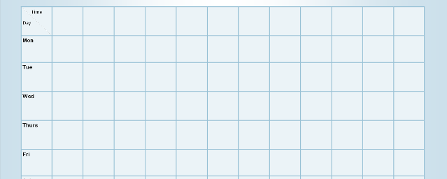 | Which lessons are good/not so good?  Why is this? (e.g., trouble keeping up, work is difficult or boring, teacher actions, behaviour management, peer difficulties)  Are there any lessons you have enjoyed previously?  What made them good?  What would you change if you could?

Help with the work in my lessons or to catch up on learning that I have missed.   | Which lessons are harder than others?  Why is this? (e.g., teaching style, curriculum content, lack of equipment, unmet learning needs, peer difficulties)  Are there any lessons you have found easier?  What made them easier?  What would you change if you could?

Support for when people are unkind or bully me in school.   | What happens?  Have you ever experienced this? (You may want to sensitively ask who is involved, what this looks like)  Where does bullying happen in school?  Are teachers aware of this? What do they do?  Is there anything else you’d like teachers to do to help?

More people to talk to or spend time with at school. | What do you normally do at break and lunch times?  Do you have friends at school?  Who would you count as a friend?  Is there anything you’d like teachers to do to help?

Help to feel like I fit in at school.   | What makes you feel this way?  Is there anything you would like to change?  Is there anything you would like others to know or understand better about you?

Other people to understand me/my needs.    This Photo by Unknown Author is licensed under CC BY-NC | What makes you feel this way?  Is there anybody who does understand you?  What do they do differently?  Is there anything you would like others to know or understand better about you?  What would happen differently if they did?

Help me to feel less tired at school.   | Tell me about your typical sleep/bedtime routine.  How do you feel when you wake up in the morning?  Does anything help you to feel more awake or wake up faster?

Help to feel less poorly or unwell at school.    This Photo by Unknown Author is licensed under CC BY-NC | *Be aware of any existing medical conditions which may contribute to this*  How do you usually feel poorly or unwell?  How would you describe this?  How severe would you rate it from 1-10.  What might make you feel a little bit better?

More support with my mental health needs which make it difficult to attend school.   | *Be aware of any existing medical conditions which may contribute to this*  Can you tell me more about that?  What might make you feel a little better in school?  What makes you feel worse in school?  Do you have any diagnoses which would be helpful for us to know about?

More support with my physical health needs which make it difficult to attend school.  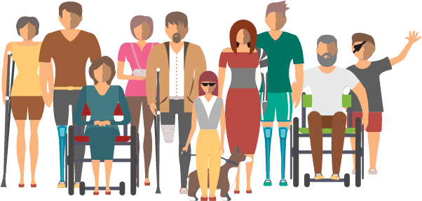 | *Be aware of any existing medical conditions which may contribute to this*  How would you describe your physical health needs?  How severe would you rate it from 1-10.  What might make you feel a little bit better or a little bit worse in school?  Do you have any diagnoses which would be helpful for us to know about?

Make changes to the school environment (e.g., make it less noisy, busy or smelly).   | It may be helpful to draw a map of the school for this activity, to identify safe or difficult areas or hotspots.  Which bits of school are better?  What would you say is overwhelming? (e.g., noise, crowding, strong smells, lighting, size, navigation)  Is there anywhere in school that you like to spend time?  Is there anywhere in school that you try to avoid?

Help me to have the right equipment for school.   | What are you missing? (e.g., stationery, uniform, lunch money)  What might help you with this?

Do more activities or lessons that I enjoy in school.   | Talk me through/draw/write about a typical day at home for you.  What activities do you like to do?  Who do you like to spend time with?

Help to feel safer in school.   | What makes you feel safe at home or school?  What makes you feel unsafe at home or school?  How safe would you say you feel at home from 1-10? How does this compare to how safe you feel at school?

There is something else.   | Is there anything else that we haven’t talked about?  What is important for the adults around you to know to help you?

E. Questionnaire for children making a fresh start

This is for young people who have had negative experiences of school and may be starting ‘afresh’ or at a new placement. The following questionnaire may help to take a retrospective look at what wasn’t working based on reasons for EBSA mentioned in research.

These are reasons other children have said made school difficult. Please be as honest as possible, if you don’t want to talk about something you have ticked as true/sometimes then tick the “I don’t want to discuss this yet” box.

Table 3: Questionnaire for children who struggle to identify barriers or are making a fresh start
I don’t want to discuss this yet | Reason | True for me | Might be true/ Sometimes | Not true for me
 | It is hard to have no control in school (lessons, timetable, uniform, rules etc.). (1)
 | School staff are mean/unfair and don't treat me with respect. (2)
 | I don't fit in with other students. (2)
 | I don't feel a part of the school community. (2)
 | School is too noisy and busy. (3)
 | The uniform is uncomfortable and distracts me. (3)
 | I am worried about the transition to high school. (4)
 | Adults in school don't listen to me. (2)
 | There is too much pressure (to attend, high workload, good grades, behave etc.). (1)
 | I was happier during Covid lockdowns and found it too hard to go back to school. (4)
 | I am exhausted. (6)
 | I’ve been off for so long now that it’s too hard to go back. (5)
 | I’ve missed too much learning to go back. (5)
 | The work is too hard, and staff don't help me. (7)
 | I’m not interested in the topics; I want to learn about things I’m interested in. (1)
 | I am/was bullied or treated unfairly (by students and/or staff). (2)
 | I feel like I’m playing a part, and it isn’t natural to me. (6)
 | I can’t concentrate for the whole school day. (7)
 | I’m scared that I can’t do it or will fail if I try. So, it’s easier to not try (then I can’t fail). (6)
 | I don’t understand the lessons and can't keep up. (7)
 | I constantly feel unsettled or uncomfortable. (6)
 | Plans keep changing (cover teachers, lesson changes, friends being off school). (4)
 | School take my phone off me, but I feel safer when I have it with me. (1)
 | I need time to ease into the school day, but they expect me to start learning straight away. (1)
 | I don't trust/believe the adults in school. They won’t/can’t help me. (2)
 | I feel trapped in school. (6)
 | Things that would help make me look different and I don’t like that. (2)
 | It’s like a wall, I want to go in, but I physically can’t. (6)
 | Writing is hard and uncomfortable, and there’s a lot of writing in school. (3 and 7)
 | When I’m asked to start the work, I don’t know what to do. (7)
 | School make me work in a pair or a group, but I want to work alone. (1, 2 and 7)
 | There is no one in school I can trust. (2)
 | School focus too much on my anxiety, but I just want to learn/work. (1)
 | People keep asking me what’s wrong, but I just don’t know. Then they seem to get annoyed with me for not knowing. (1, 2 and 6)
 | Leaving the house on time is too stressful. (4 and 6)
 | I don’t see the point in school. (6)
 | No one understands/understood me. (2)
 | People at school don’t want me. (2)

Summary
Looking at the reasons selected, use the table below to help to identify next steps. The numbers next to each statement indicate the barrier.
1 - Autonomy and pressure
2 - Relationships and a sense of belonging
3 - Sensory
4 - Managing change
5 - Difficult to return after extended time off
6 - Physical and/or mental health
7 - Learning

Table 4: Summary
Reasons | What do you think could help with this?

Section 2: Working with parents/Carers



- Start with an informal discussion with about how school is going. After this, you may feel in a position to make positive changes.
- The questionnaire below should support a more detailed conversation including what might help.

- Start with an informal discussion with about how school is going. After this, you may feel in a position to make positive changes.
- The questionnaire below should support a more detailed conversation including what might help.

Questionnaire (parent version)

What are they good at? What do they enjoy? What motivates them to learn?

When was attendance last good at school? When did the difficulties seem to start?

What impact are the attendance difficulties having on the family?

What helps them? What do you think would help them?

Adults they trust? How do they help?

Any comments about friendships?
Table 5: Questionnaire about friendship and trust
Area | Contributing Factors | Comments (e.g., yes this is an issue or not an issue)
Peer relationships | - Do they have any close friends?  - Any significant relationship breakdowns?  - Problems with social media and/or cyberbullying?  - How do they spend breaks and lunchtimes?  - Do they feel lonely? Are they socially isolated?  - Any reports of bullying?  - Do they feel different to their peers?
Staff relationships and staff approaches    This Photo by Unknown Author is licensed under CC BY-NC  This Photo by Unknown Author is licensed under CC BY-NC | - Do they have more difficulties with certain staff members/feel picked on?  - Do they feel certain teachers are too strict or not strict enough?  - Are they distressed by shouting or raised voices? Are they afraid of teachers being angry with them?  - Do they feel able to ask for help?
School environment | Are they overwhelmed or distressed by:  - Busy, noisy corridors  - Moving rooms for different lessons  - The dining hall  - Aspects of the school uniform  - Background noise  - Bright lights  - Anything else in the school environment?
Learning/ curriculum | - Fear of failure or getting into trouble  - Literacy difficulties  - Writing difficulties  - Maths difficulties  - Difficulties with understanding  - Difficulties with attention and concentration  - Problems keeping up in lessons  - Low levels of progress  - Low confidence with learning  - The work is too easy or too hard  - Certain lessons they don’t want to do?
Health and wellbeing  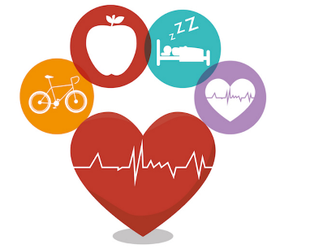 | - Does your child have any medical conditions?  - Or regular physical complaints (such as headaches or stomach aches)?  Does your child have any of the following diagnoses or areas of need?  - Autism  - ADHD  - Dyspraxia  - Dyslexia  - Speech and language difficulties  - Sleep difficulties/poor sleep routines  - Anything not listed above  Does your child say that they feel like they don’t belong?
Home factors   | - Separation, divorce or change in family dynamic  - Parent or family member has physical or mental health difficulties  - Difficulties with some family interactions  - Being the youngest in the family  - Recent loss or bereavement  - Other stress, including financial worries, housing and poverty  - Family history of EBSA  - Young carer  - Practical difficulties getting to school  - Separation anxiety  - Birth of a new sibling impacting on routine  - House moves  - Has experienced domestic abuse or other trauma

Section 3: Information gathering from staff

- At all stages of the APDR, consult key adults in school who know the child best.

- If unanswered questions remain, then it may be helpful to do a personalised round robin to all staff.

At all stages of the APDR, consult key adults in school who know the child best.

If unanswered questions remain, then it may be helpful to do a personalised round robin to all staff.

Plan

Plan

The Planning meeting
- Now hold a meeting to co-produce a plan (see template below) and use the information from the assess stage.
- Include the child, parent(s)/carers and key pastoral staff who know the child well and can advocate for them.
- Focus on what needs to change. Start with where the child is at.
- Strengths and protective factors are key considerations.
- A key aim is that everyone agrees and commits to the adjustments.
By the end of the meeting there should be clear agreement about:
  - What the school will do.
  - What parents will do.
  - What the young person will do.



Important considerations
- The return should be gradual with recognition that a ‘quick fix’ is not always possible. However, the plan should address they key factors that underlie the overwhelm and highlight the changes that will be made. This will be through additional support and/or adaptations. Suggestions can be found below.
- The plans should always be realistic and achievable. An overly ambitious plan is likely to fail.
- The timeline should be appropriate to the individual.
- Most young people want to learn, and parent(s)/carers want them in education, but the environment and curriculum have to be right.
- Try to minimise anxiety, but it is important to maintain a sense of challenge. Aim for the young person to be in their ‘stretch’ zone (this lies between comfort and danger, see MCC EBSA guidance booklet for more details).
- Everyone should stick to the plan, even if you believe the child could be doing more/staying for longer. Steps may need to be very small, and there will be setbacks.
- Pupils and parents should have a copy of their plan.

Suggested reasonable adjustments

Suggested reasonable adjustments

Table 6: Use this table to highlight agreed adjustments that can be included in the support plan
Start of the day   | A positive start to the school day can be crucial. There are many make or break factors.  Consider the following:  - Stressors on the journey to school.  - A clear plan for who will meet the child/parent and a warm welcome. The handover from parents. Where the child will go. Minimise the time spent waiting in reception and reception staff awareness.  - A separate entrance, different start/finish time to avoid busy playgrounds.  - A transition object that can be taken into school.  - Can any exemptions to usual rules be made if that would help a child to be more comfortable, e.g., keep their coat on, keep a phone with them, a snack.  - A regulation activity before going into school/lessons. Allow the time they need.  - ‘Soft starts’ to the day, e.g., breakfast club, playing a game with a friend or trusted adult, watching a TV show, time to talk with friends, a mindful activity etc.  - Reassurance about the exact plan for the day including whereabouts of a key supportive adult.
Environmental and sensory sensitivities | Consider the following:  - Access to a quiet toilet/disabled toilet, alternatives to busy corridors (e.g., 5-minute pass), alternatives to eating in a busy canteen, private changing rooms.  - Access to a safe space.  - Access to a sensory room (if available).  - Circumnavigating peers or staff that appear to pose an emotional threat (until this can be resolved).  - Seating arrangements.  - Uniform adjustments.  - Sensory adjustments (inc. fidget toys, option to move, headphones/noise cancelling ear buds such as Loop).  - Smaller rooms to sit exams in.
Timetable  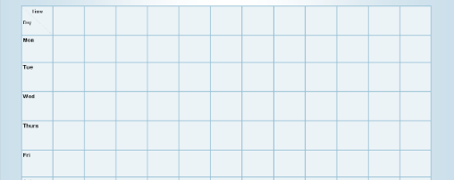 | Consider the following:  - Timetable changes including reductions or completing a lesson in a different room. RAG rating a timetable can help with this.  - Temporary exemptions from subjects causing high levels of anxiety.  - Break and lunchtime arrangements.  - A place to access remote learning while in school (if needed)
Remote education   | - Remote education can help students stay on track  - Activity packs and online learning.  - If a period of remote learning is indicated, it may be helpful to discuss with Manchester Hospital School about the criteria for AV1 telepresence robots.
Curriculum, classroom support and behaviour expectations  This Photo by Unknown Author is licensed under CC BY-SA-NC  This Photo by Unknown Author is licensed under CC BY-SA-NC | Consider the following:  - Opportunities for self-led learning following young person’s interests.  - Tutoring to address gaps in learning.  - Reduced writing requirements.  - More structured writing tasks.  - Additional support in class.  - Access to concrete materials and references (such as word banks, times table square etc.).  - Not being asked to speak in class or read aloud.  - Considerations about group/pair work.  - Homework allowances, including forgotten homework.  - Homework club.  - Exemptions from sanctions for being late (we want to focus on the attendance rather than the nonattendance).  - Exemptions from sanctions for forgetting equipment (they can work with a peer, or borrow equipment, or manage without).  - Exam access arrangements.
Emotional and wellbeing | Consider the following:  - Identification of key adults who the young person can check in with throughout the day.  - Interventions to reduce the effects of anxiety, support emotional regulation and building self-esteem, e.g., mindfulness, art, drama, music, or horticulture therapy, emotional learning support assistants (ELSAs), pastoral wellbeing sessions, mentoring etc.  - Nurture groups.  - Access to pupil support centre.  - Designated time for communicating with home if they are anxious, such a young carer or if there is a family member with health needs.  Increasing a child’s sense of belonging and ownership has been found to be effective in changing their feelings about school.
Social | Consider the following:  - Buddy systems.  - Nurture groups.  - Lunchtime and breaktime clubs.  - HAVEN (hearing, accepting and valuing every neurotype) groups through Autism in Schools. See MCC EBSA booklet

Example of a support plan
__________’s Support Plan

__________’s Support Plan

Attended by: Apologies:
Name: | Year group: | Date of birth:
Date of plan: | Current attendance: | Plan number:
Review date:

Current situation and level of engagement
E.g., time spent in lessons, time spent in school, any work completed at home (including self-led learning related to interests), what sessions are being attended?


Strengths and what’s working well

Summary of identified barriers



My key adults in school are:

When I can communicate with my key adults:

Where I can communicate with my key adults:

The following changes/adjustments will be put in place:

(These may be highlighted on the suggested reasonable adjustments outlined above, attach a copy to this plan, or outline below additional changes/adjustments)


Agreed actions

School will:

Parents/carers will:

I (child/young person) will:

Agreed priority target(s):
In 2 weeks…
In 6 weeks…

Name | Signature
Child/Young Person

Parent/Carer(s)

Staff member

Do

Do

Considerations
- Follow the plan to the letter.
- Ensure it is circulated to all members of staff who come into contact with the child (including non-teaching) and that they understand the importance of sticking to the plan.
- Have an adult monitoring the child each day to provide gentle encouragement and note what is or isn’t working.

Pitfalls
- ALL staff should be aware of the plan – no staff member must challenge a student over something in the plan, one unfortunate, misguided comment, e.g., “why did you miss my lesson?” can set the plan back.
- Staff should not comment on any absences, even ‘positive’ comments. Young people have said they hate having attention drawn to them.
- If a child seems to be doing well, resist the temptation to add additional challenge, e.g., asking if the child wants to stay for longer.

Considerations
- Follow the plan to the letter.
- Ensure it is circulated to all members of staff who come into contact with the child (including non-teaching) and that they understand the importance of sticking to the plan.
- Have an adult monitoring the child each day to provide gentle encouragement and note what is or isn’t working.

Pitfalls
- ALL staff should be aware of the plan – no staff member must challenge a student over something in the plan, one unfortunate, misguided comment, e.g., “why did you miss my lesson?” can set the plan back.
- Staff should not comment on any absences, even ‘positive’ comments. Young people have said they hate having attention drawn to them.
- If a child seems to be doing well, resist the temptation to add additional challenge, e.g., asking if the child wants to stay for longer.

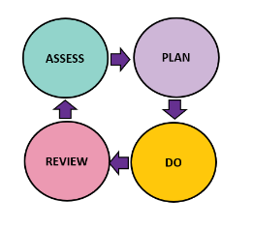

Review – Support Plan Review

Review – Support Plan Review

Attended by: Apologies:
Name: | Year group: | Date of birth:
Date of plan: | Current attendance: | Plan number:
Review date:

- For support plans to be effective we recommend a review every 2 weeks (virtual if needed).
- If there is limited or no progress, the initial steps may have been too ambitious and they need to be adjusted.
- Everyone to think about what’s going well, any challenges, further adjustments, and next steps before the meeting.
- Identify and celebrate any progress made.
EBSA often includes periods of success, followed by setbacks or regression. This is the nature of it, and it should be expected. Next steps can include:
- Consolidating and maintaining the current support plan,
- Setting new outcomes and or actions for the young person, school and parents.
- Identifying that further consultation with other agencies needs to occur which may, if necessary, lead to a referral to other services.

- For support plans to be effective we recommend a review every 2 weeks (virtual if needed).
- If there is limited or no progress, the initial steps may have been too ambitious and they need to be adjusted.
- Everyone to think about what’s going well, any challenges, further adjustments, and next steps before the meeting.
- Identify and celebrate any progress made.
EBSA often includes periods of success, followed by setbacks or regression. This is the nature of it, and it should be expected. Next steps can include:
- Consolidating and maintaining the current support plan,
- Setting new outcomes and or actions for the young person, school and parents.
- Identifying that further consultation with other agencies needs to occur which may, if necessary, lead to a referral to other services.

Updates:  Information about any key changes, progress, development etc. | 

Target | Target achieved? | Adapted target (if needed) | Agreed strategies/actions from support plan/previous meeting | What needs to change?
Agreed next steps (including by who and by when)

School will:

Parents/carers will:

I (child/young person) will:
Agreed priority target(s):

In 2 weeks…

In 6 weeks…

Name and Date | Signature
Child/Young Person
Parent/Carer(s)
Staff member

